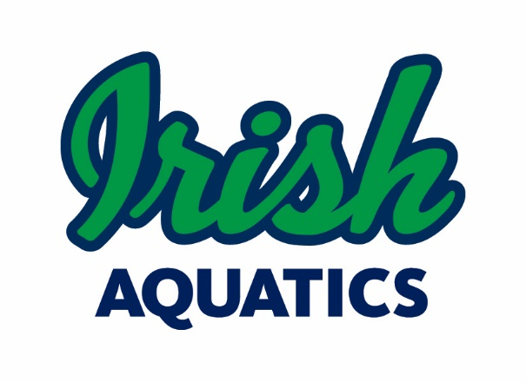
Legal Guardian Authorization for MAAPP 2.0 Exception
Local Vehicle Transportation with Unrelated Adult Participant– Single Trip

I, Parent/Guardian's Name, legal guardian of Minor Athlete's Name, a minor athlete, give express written permission, and grant an exception to the Minor Athlete Abuse Prevention Policy (MAAPP 2.0) for Individual Providing Transportation, an unrelated Applicable Adult, to provide local vehicle transportation for Minor Athlete's Name to Destination on Date at Approximate Time, and further acknowledge that this written permission is valid only for the transportation on the specified date(s) and to the specified location.

Legal Guardian Signature:
Date:

This waiver must be filled out for each instance and for each different adult member transporting the swimmer. It will remain on file with Irish Aquatics. Please send the completed form to Coach Matt (coachmatt@irishswimming.org) and the Safe Sport Chair (safesport@irishswimming.org).

