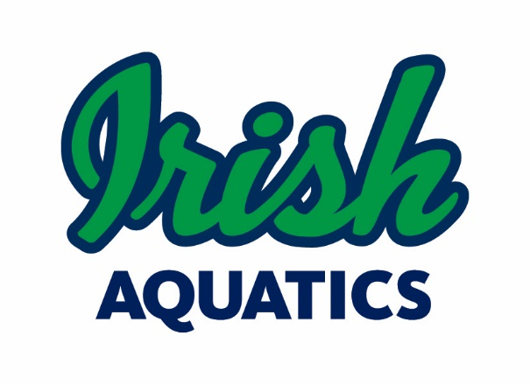
Legal Guardian Authorization for MAAPP 2.0 Exception
Mental Health Care or Health Care Professional

I, Parent/Guardian's Name, legal guardian of Minor Athlete's Name, a minor athlete, give express written permission, and grant an exception to the Minor Athlete Abuse Prevention Policy (MAAPP 2.0) for Health Care Professional's Name, a mental health care professional and/or health care provider, to have a one-on-one interaction with Minor Athlete's Name in conjunction with participation in the sport of swimming on Date at Location from Start Time to End Time. I acknowledge that this one-on-one interaction may be a closed-door meeting, provided that the door remains unlocked, another adult is present at the facility, and the other adult at the facility is advised that a closed-door meeting is occurring. I have the right to observe the massage, rubdown, or athletic training modality. I further acknowledge that this written permission is valid only for the dates and location specified herein.

Legal Guardian Signature:
Date:

This waiver must be filled out for each one-on-one session and will remain on file with Irish Aquatics. Please send the completed form to Coach Matt (coachmatt@irishswimming.org) and the Safe Sport Chair (safesport@irishswimming.org).

