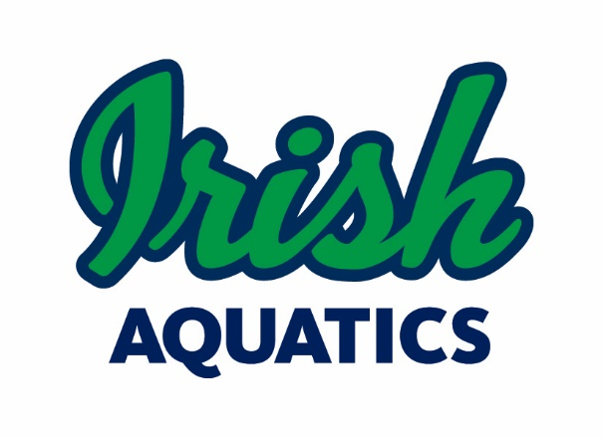
Legal Guardian Authorization for MAAPP 2.0 Exception
Minor Athlete Lodging with Close-In-Age Adult Athlete on Team Travel

I, Parent/Guardian's Name, legal guardian of Minor Athlete's Name, a minor athlete, give express written permission, and grant an exception to the Minor Athlete Abuse Prevention Policy (MAAPP 2.0) for Minor Athlete's Name to share overnight lodging accommodations in the same room with Adult Athlete Name(s) at Lodging Location from Beginning Date to End Date. I further acknowledge that this written permission is valid only for the dates and location specified herein.

Legal Guardian Signature:
Date:

This waiver must be filled out for each team travel trip and will remain on file with Irish Aquatics. Please send the completed form to Coach Matt (coachmatt@irishswimming.org) and the Safe Sport Chair (safesport@irishswimming.org).

